







The Oliver McGowan Training on Learning Disability and Autism

Expert with Lived Experience Co-Trainer

About this job

Easy

Read

Contents
Introduction 3
About the job 4
Who we are looking for 9
What you will need to do in the job 16
What is good about this job 22


Bold

words

In this Easy Read document, hard words are in bold. We explain what these words mean in the sentence after we have used them.

Introduction



We are looking for someone to start a new job with us as an expert with lived experience co-trainer.


An expert with lived experience knows a lot about something because they have lived with it in their life.

About the job

We will explain what this job is and the skills you will need.


About the job

Expert with Lived

Experience


The job is called Expert with Lived Experience Co-Trainer.

Learning

Disabilities

and Autism



The job is to train people who work in health and social care about learning disabilities and autism.

The training is called The Oliver McGowan Mandatory Training on Learning Disability and Autism.



The Oliver McGowan Mandatory Training on Learning Disability and Autism was set up after Oliver McGowan died in a hospital. Oliver was an autistic person with a learning disability. His death might have been stopped from happening.

The training will help health and social care staff to better understand the needs of people with learning disabilities and autistic people.


We will help you to feel welcome from the day you start the job so you can do the job as well as you can.

How to train people


We will teach you how to do the job.

Change


We can change the job to help you do it - this is called making reasonable adjustments.

There will be people working with you in a team who will support you to do the work.


The training includes:

Learning

disability

- Understanding learning disability.

Autism

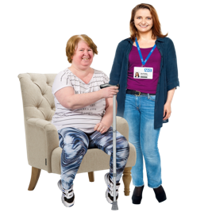
- Understanding autism.

Change

- How to make changes to support people - these are known as reasonable adjustments.

- Supporting people with a learning disability.
- Supporting autistic people with mental health conditions.


The training also includes:

- How to talk and listen to people with a learning disability or autistic people.


- Supporting young people with a learning disability.



Your job will be to help people understand how to do these things.


The training you give will be online or in person.

You can choose if you want to do online training or in person training.

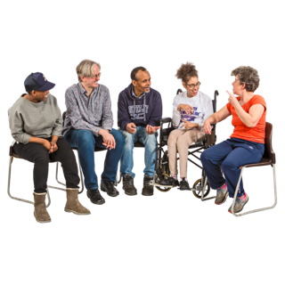





You will work with a team of trainers.

You will be helped to run the training sessions by another trainer.

You will always work with at least 1 other person. You might have another person with you to support you too.

Once you know how to give the training, we might ask you to train other people on how to give the training.


Who we are looking for

Below we will tell you about the type of person we are looking for to do this job.

Your skills and what you can do



You must be able to:

Hello





- Talk in front of people.

- Give good training to people.
- Listen to people well and understand what they are saying to you.

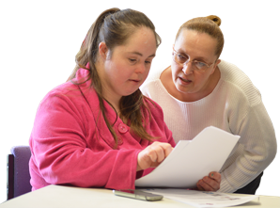
You must be able to:


- Learn what you need to do to give the training.

- Be ready and organised for the work you do.

- Organise your time so you can get your work done.
- Know what you need to do in your team and work well with them.



You must be able to:
- Work well with different types of people.


- Tell people difficult information in a positive way.
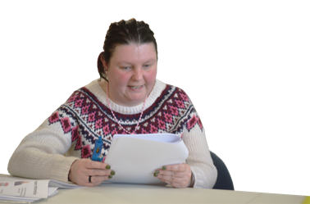
- Deal with the people you are working with in a respectful and polite way.
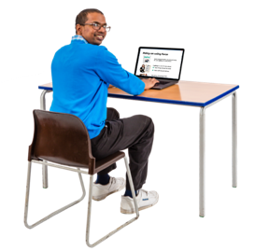
- Do your work in a careful way and spot any mistakes you make.

- Use computers to do your work, like using Microsoft Teams or Zoom and sending emails.



You must be able to:
- Travel to different places across or the South West of England.




Health

and Safety
- Understand what you need to do for health and safety when you are giving the training.




These skills and experiences will help you but you don’t need to have them to apply for the job:

- You have shared ideas and information in front of other people before.


- You are confident with using online technology, like Microsoft Teams.

- You are able to deal with some pressure. This job might be difficult at times.

Things you are or have done before

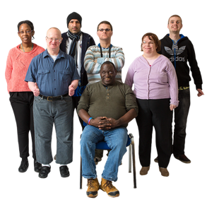

You need to:

Safe
- Have a learning disability or be an autistic person.
- Be interested in giving training to health and social care staff.
- Understand what confidentiality means - it means keeping information about other people private and safe.







It would be helpful if you have:
- Worked in a job where you needed to be respectful and polite to people you were giving a service to.
- Given training to others.
- Worked in health or social care.
- Worked in a team.
- Worked in a busy job.

Your education and training




You need to:
- Have a good level of education (English and Maths).

OR
- Have a learning disability.

OR
- Be an autistic person.


What you will need to do in the job

This is some information about what you will need to do in this job.

Who you will work with


You will work with:

- Other people in your team, like trainers and office staff.

- The people who you are giving the training to.
- People who work in health and social care organisations, like doctors, nurses, care workers, office staff and kitchen staff.

How we will help you


We will help you to:

This happened

to me


- Talk about what your life is like being autistic or having a learning disability.
- Talk about important information.

- Be comfortable with talking in front of groups of people.
- Be good at talking and listening to people and making them feel welcome.
What
about?
- Answer questions about your experiences in your life.


We will help you to:

- Get to meetings and training on time.
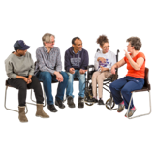
- Be trusted with private information.

How can

I help?


- Work well with other people in your team and give them support.

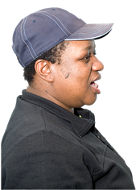
- Talk positively about The Oliver McGowan Mandatory Training.
- Tell us if you know about any problems with the training.


What you will do in the job

We will help you to:

- Work with other trainers to give training.
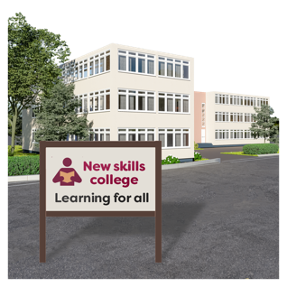


- Take part in meetings and training to get better at being a trainer.
- Be in the right place to give training at the right time.
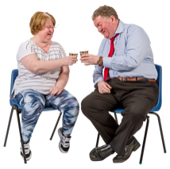

How can we

do better?

- Tell us what we are doing well and how we could make the training better.

Do you need help?
- Deal with things that you don’t expect to happen with support from your team.

What you will be in charge of doing






We will support you to:

What I think

about my work is…

What you could

do better is…
- Do your daily tasks.

- Think about how well the training you did went and share what you think with your team.
- Help new people who are starting a job with us to know what to do and settle in.
- Help new trainers to get better at their job.


Making the job better

You will be supported to:

- Give your ideas about how to make the training better.

Welcome!



- Help new members of the training team to feel welcome.
- Help new members of the training team learn how to give the training.

What is good about this job




Information about this job:

hours

Band 5
- You will work on a casual basis meaning you may not have set days or hours.
0
- You will be paid £15.00 an hour.
£15
- If your job was in the NHS, this would be a band 5 job.





Other good things about this job

The job can help you to:
- Feel good about your work.
- Learn new skills.
- Give very good training.



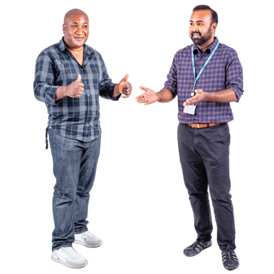
This job can help you to:
- Make people’s lives better.

- Meet new people.
- Get other jobs in the future.

This Easy Read information has been produced by easy-read-online.co.uk

